Assignment 4 Report

**Hashing using linear probing:**

Made a class called hash1 that implements a hashing function using linear probing for the employee class. The hash function is made with the employee’s name as the input and calculates the index accordingly. For the remove function in this class, if the element I want to remove is found at array[index], I swap this element with the first element of the array, and then I decrement the size of the array and shift all the elements one place ahead, removing the first element, which is now the array[index] that I want to delete.

**Hashing using chaining:**

Made a class called hash2 that implements a hashing function using chaining for the employee class. The same hash function as the one in hash1 is used.

**Main:**

I initialized 9 objects of the employee class and put down the data in the table for each employee. I then inserted each in hash2 then hash1 and printed each hash table after inserting. I then printed each hash function’s collision rate. The output is attached below:

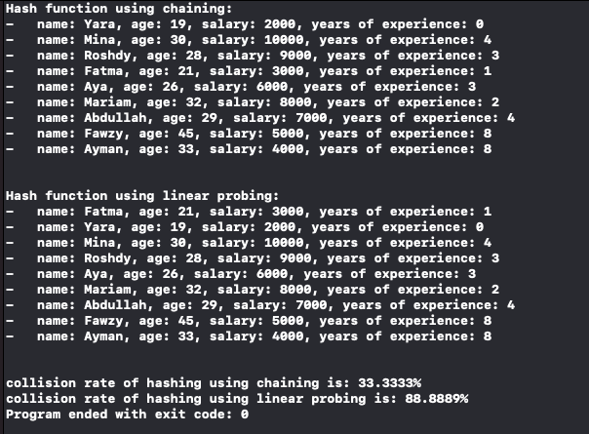

**Analysis:**

As seen in the screenshot above, hashing using chaining has a significantly lower collision rate than linear probing, so I think hashing using chaining is better in this scenario.